Language Assistance Plan

Ensuring Meaningful Access
for Limited English Proficient Individuals

September 2025

OFFICE OF CIVIL RIGHTS
2701 PROSPECT AVENUE - PO BOX 201001
HELENA, MT 59620-1001

Telephone: Voice (406) 444-6334
TTY 1-800-335-7592

Anyone needing an alternative format of this document should contact MDT’s ADA Coordinator at mmaze@mt.gov, 406-444-5416 or Montana Relay Service at 711.

Table of Contents
Part A: Introduction 2
MDT Mission & Values 2
Organization 2
Part B: Purpose of the Language Assistance Plan 3
Part C: Authorities and Guidance 3
Part D: Determining MDT’s Obligation to Provide LEP Services (Four-Factor Analysis) 4
Factor 1: The number or proportion of LEP individuals eligible to be served or likely to be encountered by MDT staff 5
Montana Residents 5
Non-Residents 5
Factor 2: The frequency with which LEP individuals come in contact with MDT Programs 6
Factor 3: The nature and importance of the program or service provided by the program to people’s lives 6
Factor 4: The resources available to MDT Program staff and resource costs 7
Part E: Elements of MDT’s Language Assistance Plan 7
Element I: Identifying Language Needs of LEP Individuals 7
Public Engagement 8
Element II: Language Assistance Measures 8
Safe Harbor for Written Translations 8
Language Assistance Measures 8
How to Assist LEP Individuals 9
Element III: Training Staff 9
Element IV: Providing Notice to LEP Persons 10
Tribal Communities 10
Public Engagement 10
Websites and Online Documents 10
Element V: Monitoring and Updating the LAP 11
Attachment A: ACS Tables 12
Attachment B: FMCSA ELP Memorandum 15
Attachment C: Point to Your Language Poster 21
Attachment D: Resources 22

Part A: Introduction

MDT Mission & Values
The mission of the Montana Department of Transportation (MDT) is to plan, build, operate, and maintain a safe and resilient transportation system to move Montana forward.
The core values that guide all MDT employee behavior, actions and approach are: Safety, Accountability, Customer Service, Leadership, Communication, Decision-Making and Disagreement, and Excellence.

Organization
MDT is responsible for the planning, design, maintenance, operation, and management of Montana’s state-owned roadways, walkways, rest areas, airports, and numerous public-use facilities. The departmental structure helps staff at the state, regional, and local level efficiently deliver transportation improvements, comply with relevant rules and regulations, and maintain and operate transportation infrastructure to enable daily movement of goods and people across the state.

Each division within the department provides a critical function toward meeting MDT’s mission of ensuring Montana’s transportation network continues to remain a quality resource for all users, and supports the growth of businesses, communities, and the Montana way of life. MDT’s leaders, employees, and partners are focused on the future of our state and finding the best ways to move Montana forward, together.

Montana’s geographic and demographic diversity means regions in Montana face different travel demands and transportation challenges. To address these unique challenges, the state is split into five transportation districts, each managed by district administrators focused on the individual transportation needs within their jurisdiction.

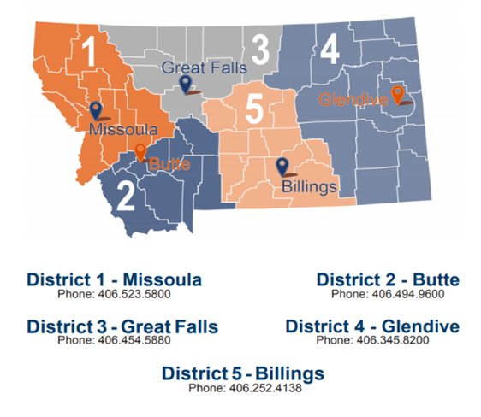

Part B: Purpose of the Language Assistance Plan
As a recipient of federal financial assistance, MDT is required to comply with Title VI of the Civil Rights Act of 1964 and related statutes, regulations, and authorities, and to deliver its federally assisted programs, services, and activities (Program(s)) in a fair and nondiscriminatory manner. This includes taking reasonable steps to provide limited English proficient (LEP) individuals with meaningful access to all MDT Programs. LEP individuals do not speak English as their primary language and have limited ability to speak, read, write or understand English. The purpose of the MDT Language Assistance Plan (LAP or Plan) is to ensure MDT communicates effectively with LEP individuals.
Meaningful access means providing language assistance that results in accurate, timely, and effective communication at no cost to the LEP individual. For LEP individuals, meaningful access denotes access that is not significantly restricted, delayed, or inferior compared to access provided to English proficient individuals.

This LAP provides guidance to MDT Programs for identifying LEP individuals, implementing language assistance measures, and defining staff responsibilities related to providing meaningful access for LEP individuals.

MDT subrecipients may reference this Plan to address LAP/LEP responsibilities. In referencing this Plan, subrecipients must independently ensure compliance with the subrecipient’s specific LAP/LEP requirements.

For further questions regarding this Plan, please contact:

Kim Vietz, Title VI Specialist
Montana Department of Transportation
Office of Civil Rights
406-444-6334
kvietz@mt.gov

Part C: Authorities and Guidance
Title VI of the Civil Rights Act of 1964, 42 U.S.C. 2000d, provides that no person “shall, on the ground of race, color, or national origin, be excluded from participation in, be denied the benefits of, or be subjected to discrimination under any program or activity receiving Federal financial assistance.”

U. S. Department of Justice (USDOJ) LEP Guidance, “Enforcement of Title VI of the Civil Rights Act of 1964 - National Origin Discrimination Against Persons with Limited English Proficiency,” (August 11, 2000) directs each Federal agency to examine the services it provides and to develop and implement a system by which LEP individuals can meaningfully access those services and requires federal fund recipients to take reasonable steps to ensure meaningful access to Programs for LEP individuals.
U.S. Department of Transportation (USDOT) LEP Guidance, “Policy Guidance Concerning Recipients' Responsibilities to Limited English Proficient (LEP) Persons,” (December 14, 2005) requires USDOT recipients take reasonable steps to ensure meaningful access to Programs for LEP individuals.
USDOT FTA Circular 4702.1B, “Title VI Requirements and Guidelines for Federal Transit Administration Recipients,” (October 1, 2012) Chapter III, part 9, requires federal fund recipients and subrecipients take reasonable steps to ensure meaningful access to Programs for LEP individuals.
Executive Order 14224, “Designating English as the Official Language of the United States,” 90 FR 11363 (March 1, 2025) designates English as the one official language of the United States.

USDOT Federal Motor Carrier Safety Administration (FMCSA), “English Language Proficiency Under 49 CFR § 391.11(b)(2),” MC-SEE-2025-0001 (May 20, 2025) (FMCSA ELP Memorandum) requires placing drivers of commercial motor vehicles (CMV) out of service for English Language Proficiency (ELP) violations, defines the driver assessments for determining non-compliance with 49 CFR 391.11(b)(2), and requires MCS officers to communicate in English with CMV drivers during the driver interview. If the officer determines that the driver is in compliance, the officer may elect to conduct the remainder of the inspection using communication methods best suited to facilitate safe and effective completion of the inspection.

Part D: Determining MDT’s Obligation to Provide LEP Services (Four-Factor Analysis)
MDT uses the following four factors to evaluate its obligation to provide LEP
services:

Factor 1. The number or proportion of LEP persons eligible to be served or likely to be encountered by MDT program staff.
Factor 2. The frequency with which LEP individuals interact with the program.
Factor 3. The nature and importance of the program, activity, or service provided by the program.
Factor 4. The resources available to MDT’s programs and resource costs.

The following four-factor analysis provides an agency-wide assessment for all of MDT’s Programs. If sections of this assessment do not apply to specific programs, MDT program staff should work with OCR to conduct a more specific four-factor analysis to determine appropriate steps to ensure meaningful access for LEP individuals.

Factor 1: The number or proportion of LEP individuals eligible to be served or likely to be encountered by MDT staff
Programs that encounter a greater number of LEP individuals are more likely to require language assistance services. Since MDT Programs serve both Montana residents and non-residents, this analysis considers resident and non-resident LEP individuals.

Montana Residents
MDT evaluated the following external data sources linked from LEP.gov Data and Language Maps to determine the best resources to evaluate the number of residents likely to be served or encountered by MDT Programs:
- Federal Government LEP Map Apps.
- U.S. Census Bureau LEP Data.
- U.S. Department of Health and Human Services LEP data.
- U.S. Department of Education (USDOE) LEP data.
- Non-Governmental LEP Data and Maps.
See also, Attachment D: Resources. In addition, MDT consulted the Montana Department of Administration and the Montana Department of Commerce Census and Economic Information Center (CEIC). MDT also reviewed data from the Montana Office of Public Instruction. MDT determined that US Census Bureau and CEIC census data from the 2021 ACS 5-Year Estimates yielded the most accurate information.
Statewide census data indicated 0.76% of Montanans spoke English less than very well, with Spanish (0.3%) being the most commonly spoken non-English language. Census data in Attachment A, listed by county, identified 11 (of 56) counties in Montana where more than 1% of the population spoke English less than very well; however, no geographic area had a language use percentage other than English greater than 2.8%.
USDOE data from Fall 2021 indicates that 2.4% of Montana’s public school students were English learners.

Non-Residents
Several MDT programs that interact with LEP individuals are not included in these external data sources as the individuals do not reside in Montana. In June 2022, to better understand and capture interactions with these populations, MDT surveyed its employees to determine the total number of interactions between staff and LEP individuals within the past year.

Factor 2: The frequency with which LEP individuals come in contact with MDT Programs
MDT utilized data from its employee survey to assess the frequency with which LEP individuals come in contact with MDT Programs.
- Of the 747 MDT employee survey respondents, 3.8% reported interactions with Spanish speaking LEP individuals during the year. MDT employee respondents reported Spanish as the language most frequently encountered.
  - 26% of MDT employee respondents that work directly or indirectly with members of the public encountered at least one LEP individual during the survey period.
  - MDT district office employees generally reported 5 or fewer encounters per year with LEP individuals. Most of these encounters involved serving the traveling public.
  - Motor Carrier Services (MCS) employees were the most likely to encounter LEP individuals, as 50% of MCS respondents encountered LEP individuals more than 26 times in a year. MCS respondents reported languages most frequently encountered as: Arabic, French, Punjabi, Russian, Spanish, and Urdu.

MDT reviewed survey results from the Yellowstone Airport in West Yellowstone, Montana and Yellowstone National Park (YNP). Both MDT Yellowstone Airport and YNP Visitor Use Study (2016) respondents reported languages most frequently encountered as Mandarin and Spanish.
MDT also surveyed transit subrecipients in November 2022. The survey results indicated the following:
- 32% of MDT subrecipient respondents reported encountering at least one LEP individual (e.g., subrecipients answered “1-5 encounters” or “more than 26 encounters”) in the past year, most often a transit rider.
  - Subrecipient respondents reported Spanish as the language most frequently encountered.

Factor 3: The nature and importance of the program or service provided by the program to people’s lives
The more important the program, or the greater the possible consequences of the contact to LEP individuals, the greater the need for language assistance services. MDT staff must determine whether denial or delay of access to programs could have serious implications for the LEP individual. Although all MDT Programs are important, generally, programs related to accessing benefits, opportunities, or rights are considered high importance.
Areas of high importance typically are:
- Programs that serve higher minority or LEP populations (i.e., Indian reservations); and
- Programs where the population is non-residential (e.g., airports, Motor Carrier Services, and district staff assisting the traveling public).

Factor 4: The resources available to MDT Program staff and resource costs
The frequency and importance of MDT Program encounters for Montana’s LEP populations will dictate the level of language services it should commit to provide. Some language services can be provided at little or no cost. Each Program should carefully explore the most cost-effective means of delivering competent and accurate language services by:
  - Taking an inventory of the language assistance measures currently being provided, along with associated costs.
  - Contacting OCR to determine what, if any, additional services are needed to provide meaningful access.
  - Considering cost-effective practices for providing language services

Montana’s demographic does not meet the threshold for written translation in any languages; however, the survey indicated that MDT Programs do encounter LEP individuals and need to be equipped to provide meaningful access. MDT provides the Language Identification and Assistance Guide to MDT employees, which prepares them to know when and how to provide interpretation services when interacting with LEP individuals.
Language assistance measures should be based on what is necessary and reasonable after considering the four-factor analysis. See Element II, Language Assistance Measures on page 9 for further information.

Part E: Elements of MDT’s Language Assistance Plan
Based upon the findings in the four-factor analysis, MDT staff will implement language assistance measures to address the identified needs of LEP populations served. MDT uses the following five elements from USDOT LEP Guidance to implement its Plan:
- Identifying the Language Needs of LEP Individuals.
- Implementing Language Assistance Measures.
- Training Staff to Implement the Plan.
- Providing Notice to LEP Individuals.
- Monitoring and Updating the LAP.

Element I: Identifying Language Needs of LEP Individuals
MDT’s assessment of the number of LEP individuals eligible to be served or encountered and the frequency of encounters is documented through the four-factor analysis in Part D of this Plan.

ACS and employee survey data will not provide Title VI demographic data for all situations. Some Title VI impacts, such as right of way/relocations and public involvement, will require MDT to conduct surveys to collect demographic data from impacted persons.

Public Engagement
MDT’s public involvement process ensures consistent communication that informs the public and stakeholders from initial project development through the completion of construction. To enhance communication on a project specific and statewide level, MDT contracts with six public involvement firms. As described further in Element III on page 10, OCR trains MDT employees and public involvement firms on LEP requirements, including language assistance measures in Element II and public notice requirements for public engagement in Element IV.

Element II: Language Assistance Measures
MDT uses various language assistance services to ensure meaningful access for LEP individuals. Language assistance measures should follow USDOT LEP guidance and be based on what is necessary and reasonable after considering the four-factor analysis in Part D of this Plan.

Safe Harbor for Written Translations
MDT follows USDOT LEP guidance regarding “safe harbor” provisions for translation of written documents. Under these provisions the following actions are considered strong evidence of compliance with USDOT’s written-translation obligations:
Size of Language Group | Recommended Provision of Written Language Assistance
1,000 or more in the eligible population in the market area or among current beneficiaries | Translated vital documents
More than 5% of the eligible population or beneficiaries and more than 50 in number | Translated vital documents
More than 5% of the eligible population or beneficiaries and 50 or less in number | Translated written notice of right to receive free oral interpretation of documents.
5% or less of the eligible population or beneficiaries and less than 1,000 in number | No written translation is required.

Based on MDT’s analysis of ACS data identifying language spoken at home, MDT does not meet the threshold requiring written translations of vital documents; however, MDT has arranged to provide interpretation and translation services to LEP individuals to ensure meaningful access to MDT Programs.

Language Assistance Measures
- MDT’s Language Identification and Assistance Guide (Guide) equips employees to identify the primary language of the LEP individual (“I Speak…”) and how to obtain interpretation services via Language Link. For MCS officers, MDT included in the Guide an explanation of why a driver is receiving a Commercial Vehicle Safety Alliance inspection and what documents are being requested. This information is translated into the six most common languages encountered by MCS officers (Arabic, French, Punjabi, Russian, Spanish, and Urdu).
- MDT’s Yellowstone Airport uses universal airport signage and graphics to assist with airport terminal and landside wayfinding. The signs are used internationally and can help passengers identify where airport services are located without having to read or understand English.
- MDT contracts with Language Link to deliver interpretation and translation services in more than 300 languages and dialects. Language Link is available 24 hours a day, 7 days a week, year-round. MDT’s contract also includes these services for its subrecipients.

How to Assist LEP Individuals
Necessary language assistance may vary depending on the type of interaction.
LEP Callers and LEP Individuals who have In-Person Contact with Staff: MDT employees should use the Language Identification and Assistance Guide to determine the primary language of the LEP individual and contact Language Link to provide interpretation.
To ensure the best interaction when working with interpreters, MDT employees should:

- Briefly tell the interpreter the nature of the call.
- Speak directly to the LEP individual and not to the interpreter.
- Pause at the end of a complete thought.
- Provide the interpreter with clarification or repetition as requested to ensure accuracy.

Written Communication from LEP Persons: Written translation requests may take up to five (5) business days to receive from the date of request. To provide timely service, MDT staff should call the LEP individual using Language Link to respond. For formal written responses that need to be translated, contact MDT OCR to request a translation from Language Link.

Element III: Training Staff
MDT employees need to know their obligations to provide meaningful access to programs for LEP individuals. MDT will provide training for all employees, which includes:
- Review of MDT’s current LAP and LEP policies and procedures.
- Requirements for providing meaningful access.
- How to work effectively with LEP individuals and interpreters.
- Coordinating with OCR to document LEP interactions.
- How to use available resources including the Language Identification and Assistance Guide and Language Link.
OCR will annually assess agency employee training needs for providing meaningful access to LEP individuals, including training of management staff and new employees.

Element IV: Providing Notice to LEP Persons
Any facilities where MDT interacts with the public in-person should have a “Public Notice of Rights Under Title VI” posted clearly and conspicuously. Based on EO 14224, MDT’s four-factor analysis and USDOT’s safe harbor guidance, notices will be published in English. MDT will also post the Point to Your Language Poster, a resource from Language Link, in all public-serving facilities. Staff should use the Language Identification and Assistance Guide in interactions with LEP individuals. If staff experience an increase in LEP individuals accessing MDT programs, they should work with OCR to document and determine if additional resources should be provided to ensure meaningful access.

Tribal Communities
MDT acknowledges tribal languages may be spoken in reservation communities or elsewhere in Montana. MDT employees can use Language Link to assist with interpretation or translation services.

Public Engagement
MDT must consider LEP communities during all public engagement planning. If LEP communities were not previously included in the MDT assessment, employees should contact OCR to document the four-factor analysis and determine the level and type of language assistance necessary for a particular public engagement plan or activity.
MDT employees should be prepared to provide language assistance via Language Link throughout the public engagement process, whether the public engagement is virtual or in person. The Guide provides information on how to connect to Language Link through a virtual platform. Staff should determine what information the LEP individual is interested in receiving. If the information is not readily available in other languages, staff should request the LEP individual’s contact information and follow up with the requested information in a timely manner.
MDT employees conducting outreach should regularly assess the needs of the populations frequently encountered or affected by their program to determine whether translation of outreach materials is needed. Community organizations may help determine what outreach materials are most helpful to translate, and some translations may be more effective when done in conjunction with other outreach methods, including utilizing ethnic media, schools, and religious or community organizations to help spread a message.

Websites and Online Documents
Generally, MDT websites are considered a statewide resource, and the four-factor analysis should use statewide LEP data to determine necessary translations. However, where MDT employees determine a more specific LEP audience is likely to visit their webpage(s), the four-factor analysis should include a demographic analysis limited to that audience. For example, a district maintaining a project-specific webpage should consider the population likely to be affected by the project.

Element V: Monitoring and Updating the LAP
OCR will be responsible for reviewing changes in demographics and types of language assistance services to update and implement the LAP on an annual basis. This includes assessing changes in:
- Executive Orders and/or legislation.
- Current LEP populations in the service area or population affected or encountered.
- Frequency of encounters with LEP language groups.
- Nature and importance of activities to LEP individuals.
- Availability of resources, including technological advances and sources of additional resources, and the costs imposed.
- Whether existing assistance meets the needs of LEP individuals.
- Whether staff knows and understands the LAP and how to implement it.
- Whether identified sources for assistance are still available and viable.

Any changes will be reflected in future Plan updates.

Attachment A: ACS Tables
As shown below, Census data indicates 0.76% of Montanans speak English less than very well with Spanish (0.3%) being the most commonly spoken non-English language.
Montana & Counties: Population 5 years and over that speaks English less than very well
Data Source: 2021 American Community Survey (ACS) 5-year
Table: C16001
CEIC refined ACS Table C16001 to be Montana-specific (April 6, 2023). The below table is an excerpt from the CEIC document. The full document is available upon request.

Geography Name | Language | % of Population 5 years and over that speak English less than very well
Montana | All Languages other than English | 0.76%
Montana | Arabic | 0.02%
Montana | Chinese (incl. Mandarin, Cantonese) | 0.06%
Montana | French, Haitian, or Cajun | 0.02%
Montana | German or other West Germanic languages | 0.10%
Montana | Korean | 0.01%
Montana | Other and unspecified languages | 0.04%
Montana | Other Asian and Pacific Island languages | 0.06%
Montana | Other Indo-European languages | 0.03%
Montana | Russian, Polish, or other Slavic languages | 0.05%
Montana | Spanish | 0.30%
Montana | Tagalog (incl. Filipino) | 0.02%
Montana | Vietnamese | 0.03%

ACS Table C16001 includes the primary language spoken for the state and countywide population who speak English less than very well. ACS Table S1601 combines all LEP individuals by county, regardless of primary language spoken. MDT evaluated both ACS Tables and due to smaller LEP populations, MDT chose to review counties by all LEP populations within a county instead of by individual primary language. As shown below, in 11 of the 56 counties in Montana more than 1% of the population spoke English less than very well; however, no geographic area had a language use percentage other than English greater than 2.8%.

Montana & Counties: Population 5 years and over that speaks English less than very well
Data Source: 2021 American Community Survey (ACS) 5-year
Table: S1601
CEIC refined ACS Table S1601 to be Montana-specific (April 6, 2023). The below table is an excerpt from the CEIC document. The full document is available upon request.

Geographic Area Name | % of Population 5 years and over that speak English less than very well
Montana | 0.76%
Beaverhead County | 1.19%
Big Horn County | 0.27%
Blaine County | 0.32%
Broadwater County | 0.25%
Carbon County | 0.71%
Carter County | 0.00%
Cascade County | 0.95%
Chouteau County | 0.36%
Custer County | 0.99%
Daniels County | 0.12%
Dawson County | 0.22%
Deer Lodge County | 0.56%
Fallon County | 0.00%
Fergus County | 0.56%
Flathead County | 0.70%
Gallatin County | 0.62%
Garfield County | 0.00%
Glacier County | 2.03%
Golden Valley County | 1.13%
Granite County | 0.32%
Hill County | 0.42%
Jefferson County | 0.74%
Judith Basin County | 0.10%
Lake County | 1.59%
Lewis and Clark County | 0.64%
Liberty County | 2.07%
Lincoln County | 0.79%
McCone County | 0.47%
Madison County | 1.81%
Meagher County | 0.00%
Mineral County | 0.00%
Missoula County | 1.18%
Musselshell County | 0.52%
Park County | 0.59%
Petroleum County | 0.00%
Phillips County | 0.00%
Pondera County | 2.41%
Powder River County | 0.25%
Powell County | 0.24%
Geographic Area Name | % of Population 5 years and over that speak English less than very well
Prairie County | 0.51%
Ravalli County | 0.31%
Richland County | 0.86%
Roosevelt County | 0.43%
Rosebud County | 0.79%
Sanders County | 0.28%
Sheridan County | 0.42%
Silver Bow County | 1.38%
Stillwater County | 0.21%
Sweet Grass County | 0.55%
Teton County | 0.24%
Toole County | 1.61%
Treasure County | 0.00%
Valley County | 0.06%
Wheatland County | 0.00%
Wibaux County | 2.80%
Yellowstone County | 0.61%

Attachment B: FMCSA ELP Memorandum
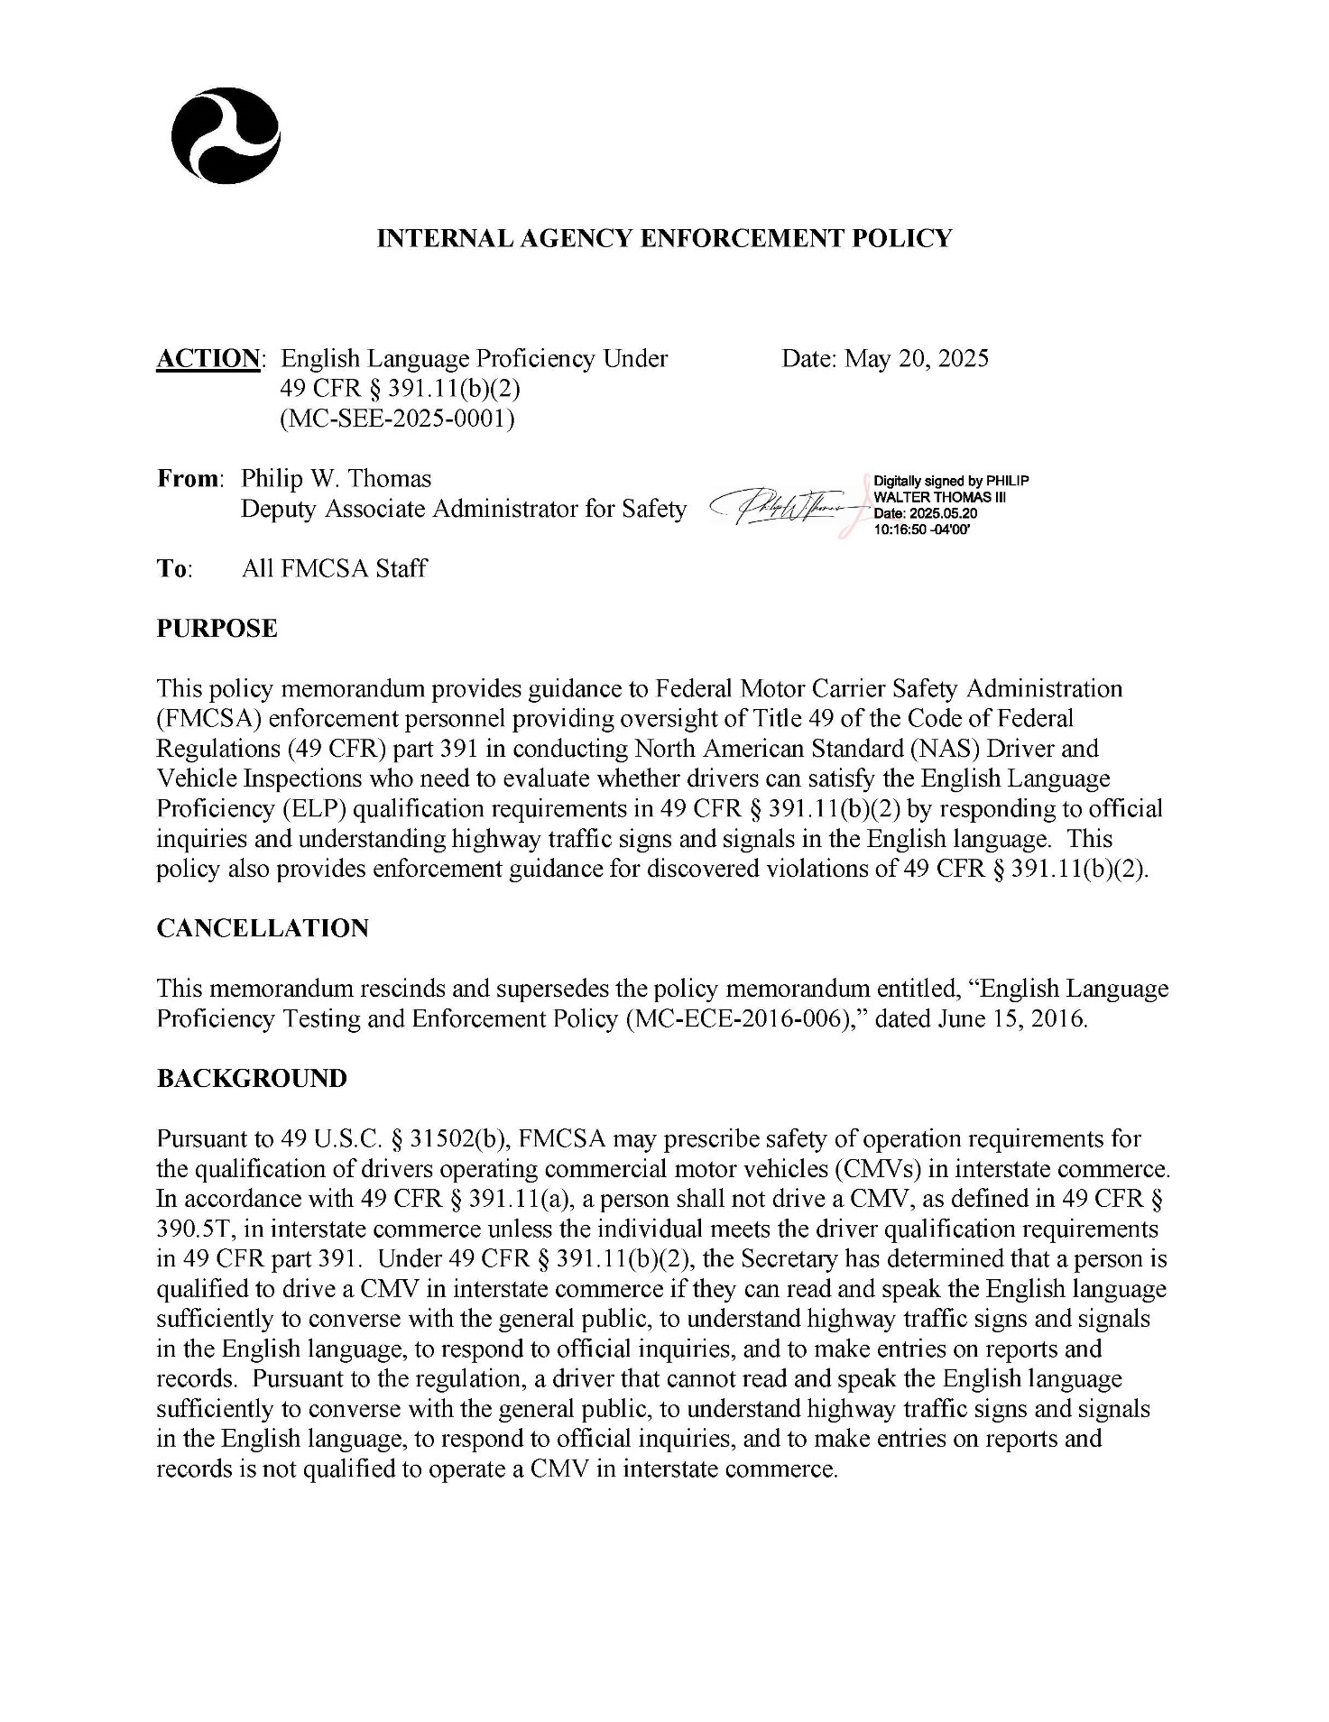

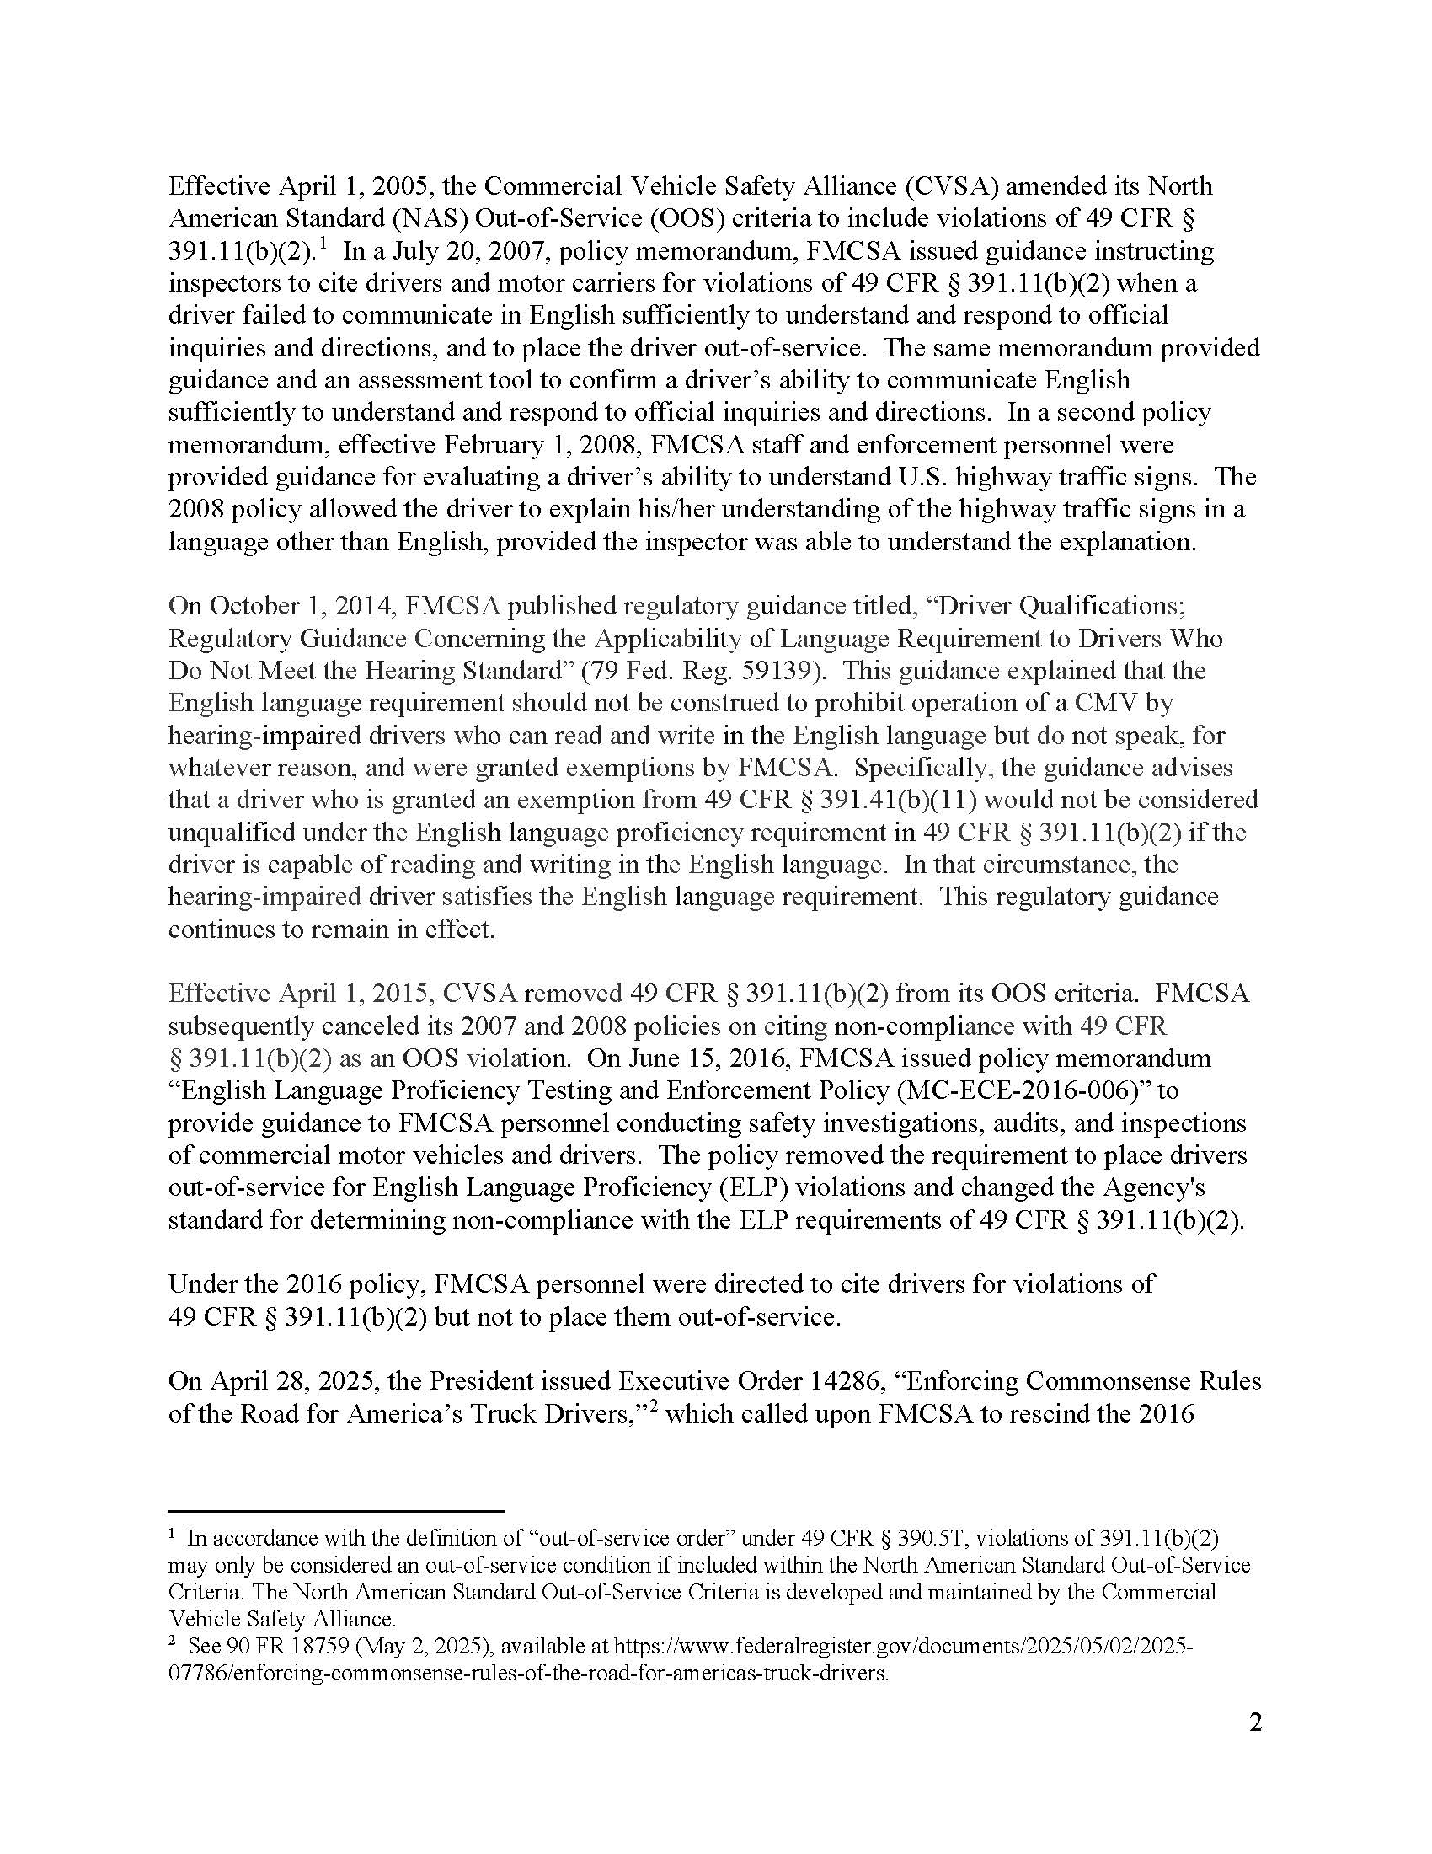

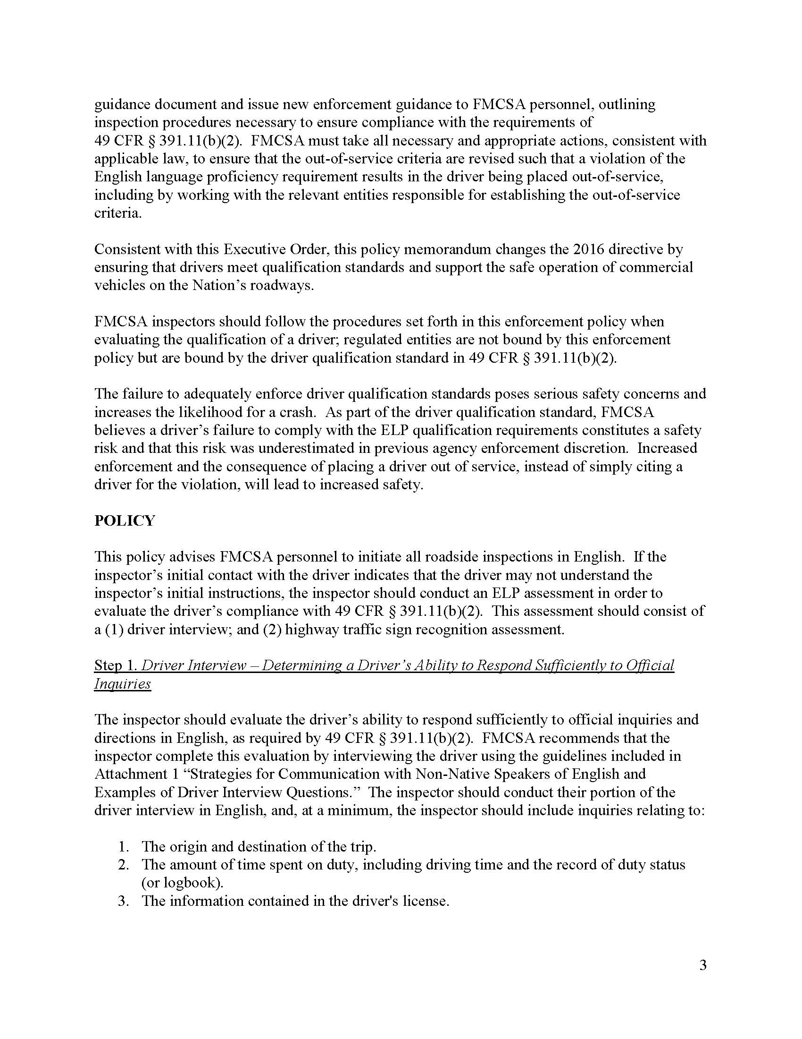

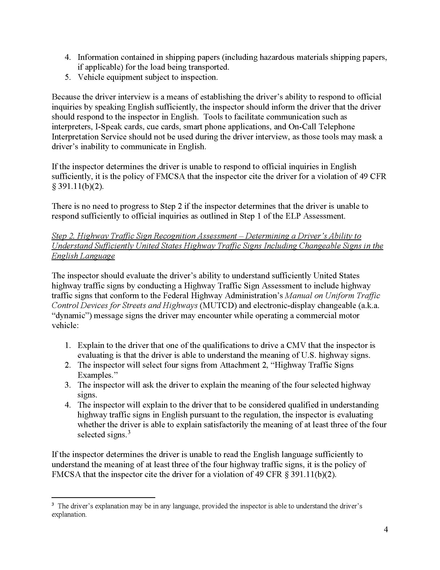

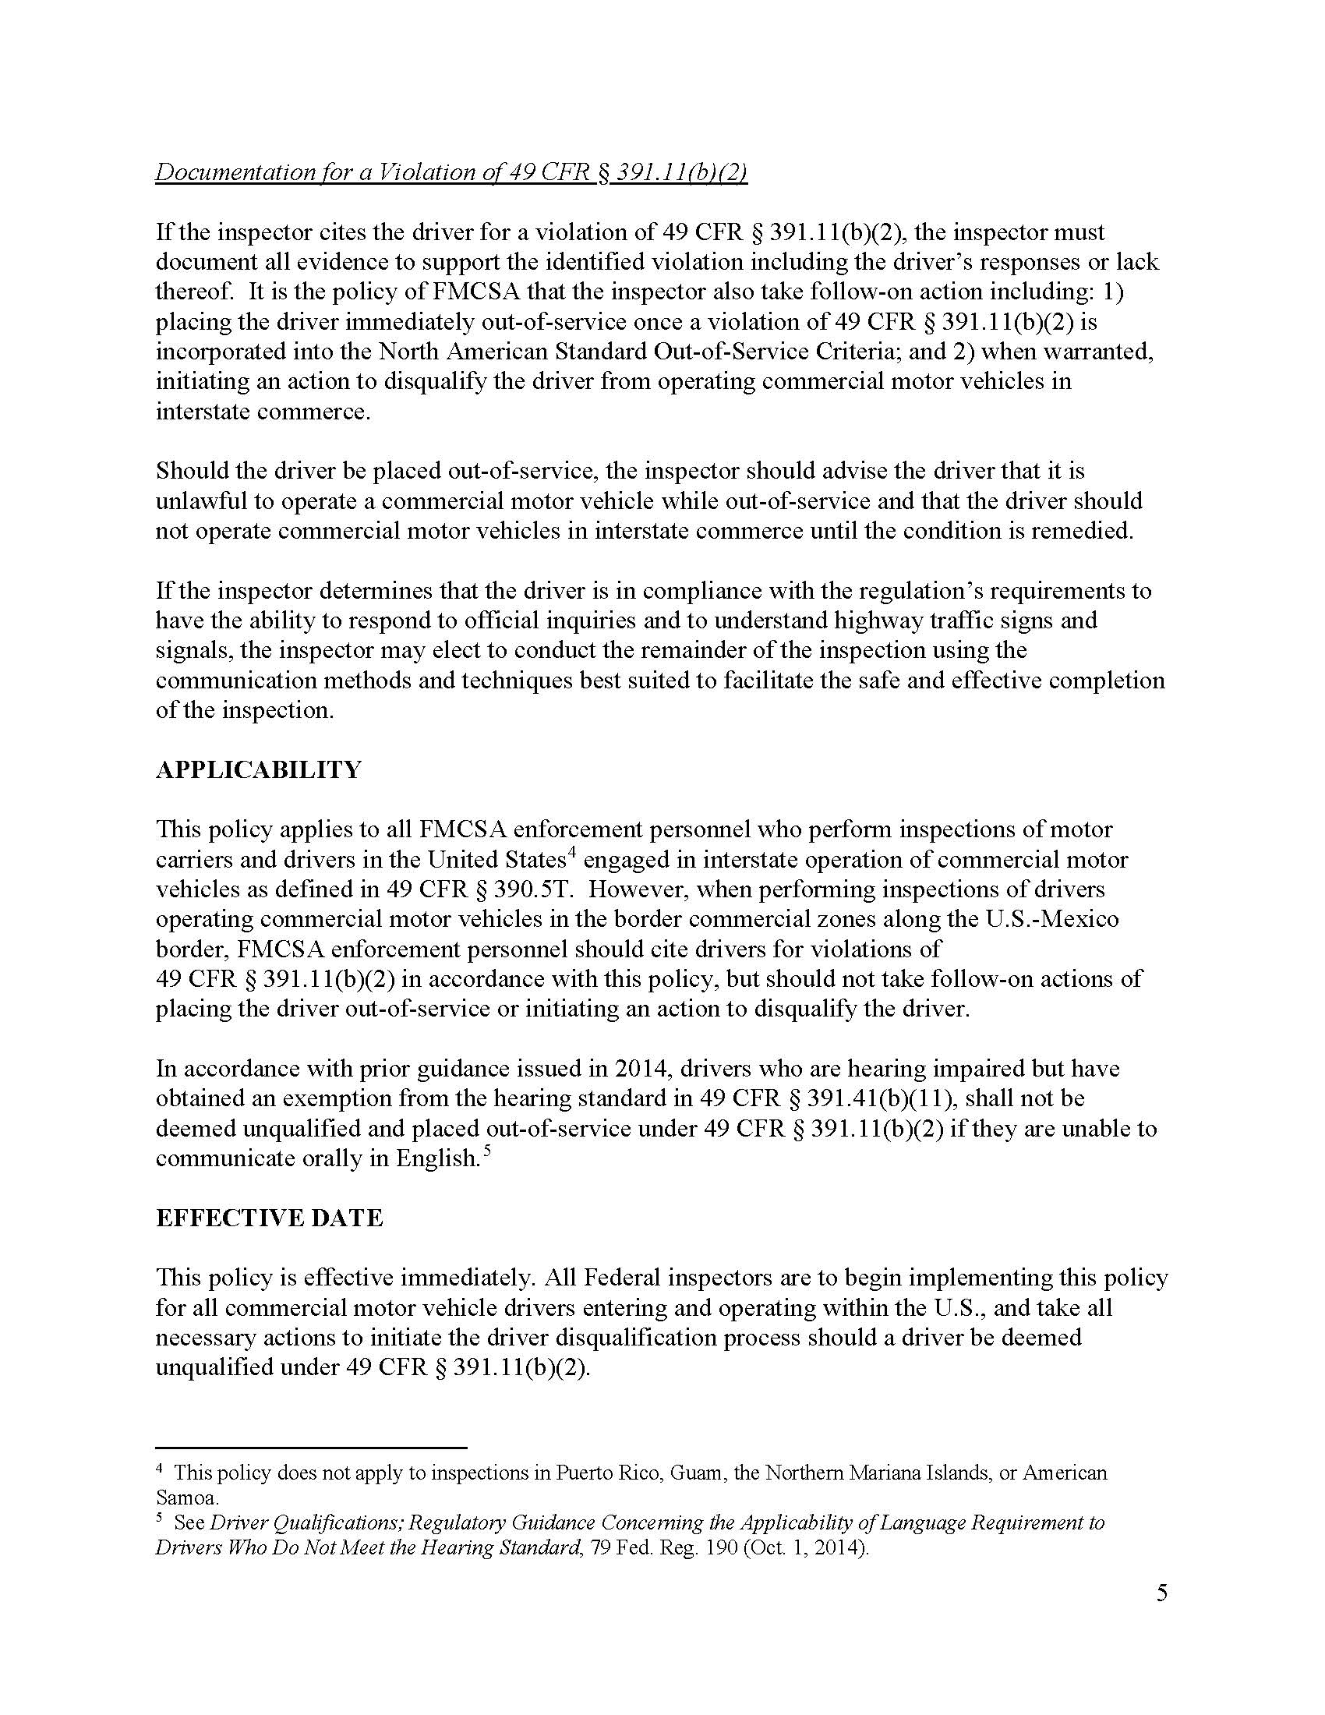

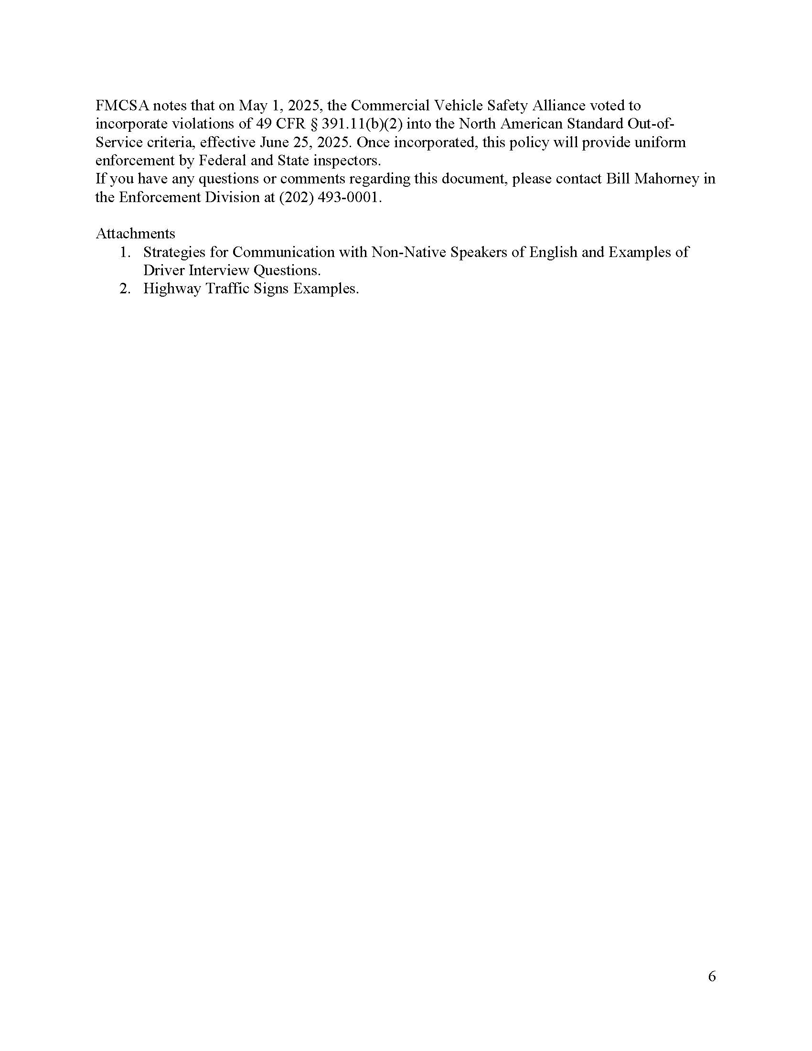

Attachment C: Point to Your Language Poster

Attachment D: Resources
MDT evaluated the following external data sources from LEP.gov Data and Language Maps to determine the best resources to evaluate the number of individuals likely to be served or encountered by a Program:
- Federal Government LEP Map Apps
  - Refers to U.S. Census Bureau LEP data, which is discussed in the next bullet.
- U.S. Census Bureau LEP Data
  - The most current resources at the statewide level refer to American Community Survey (ACS) data. ACS is a nationwide survey designed to provide communities with reliable and timely social, economic, housing and demographic data every year. No other resource provides such a wealth of social, economic, housing, and demographic information for the nation, states, and substate geographic areas.
- U.S. Department of Education (USDOE) LEP data
  - Includes National Center for Education Statistics (NCES) for English Language Learners (ELL) on a statewide level. An English learner is an individual who has sufficient difficulty speaking, reading, writing, or understanding the English language to be denied the opportunity to learn successfully in classrooms where the language of instruction is English or to participate fully in the larger U.S. society.
    - MDT also evaluated Montana Office of Public Instruction (OPI) data since USDOE data is at a statewide level. Data from OPI is broken down by school district and does not indicate a student’s fluency in English nor what language is spoken at home. MDT compiled the OPI data by school district, but elected not to use it because the data does not provide the level of information needed for determining LEP populations likely to be served.
- Non-Governmental LEP Data and Maps
  - MDT elected not to use any of the resources listed under this section because data was either provided at the nationwide level, was based on statistics from several years ago, or used ACS data that MDT already evaluated.
- The Census and Economic Information Center (CEIC) within Montana Department of Commerce is the official State Data Center for the state. CEIC provides current, easily accessible, and thorough economic and demographic analysis, data, maps, and expert assistance to meet the needs and requests of the people in the State of Montana. CEIC prepared census data for MDT from the 2021 ACS 5-Year Estimates, Table C16001 and S1601, which indicate language spoken at home for the population 5 years and older and whether English is spoken “very well” or less than “very well.”

Program(s) include any activities, benefits, information, programs, projects or services provided by or delivered from any MDT division or district office.
For the convenience of subrecipients and to optimize compliance with LAP/LEP requirements, MDT has arranged for subrecipients’ no-cost use of MDT’s contracted services for language assistance. Notwithstanding this arrangement, subrecipients remain responsible for complying with their respective LAP/LEP requirements. See e.g., USDOT Federal Transit Administration (FTA) Circular 4702.1B, Chapter III-7 through III-9.
FMCSA ELP Memorandum is Attachment B.
See four-factor analysis in USDOJ and USDOT LEP Guidance.
USDOT LEP Guidance.
LEP.gov is no longer available as of this update.
Resource for Entities Covered by Section 1557 of the Affordable Care Act Estimates of at Least the Top 15 Languages Spoken by Individuals with Limited English Proficiency for the 50 States, The District of Columbia, and the U.S. Territories (no longer available as of this update).
The CEIC is the official State Data Center for Montana. The State Data Center program is one of the Census Bureau’s partnerships to make data available locally.
MDT evaluated the data from ACS Table C16001 and S1601 because it had the most recent data (2021) and provided data at the county level.
ACS Table C16001 as refined by CEIC to be Montana-specific is available upon request.
USDOE English Learners in Public Schools by State.
MDT Limited English Proficiency Survey (June 2022) is available upon request.
YNP Visitor Use Study is available upon request.
See Safe Harbor for Written Translations under Element II.
FHWA Limited English Proficiency Data Collection Walkthrough.
“I Speak…” is translated into 71 languages, including those from Montana’s tribal communities.
Language Link partners with other federal, state, and local government entities and maintains certifications and standards within its industry. MDT employees should refer to the Guide, MDT website, or contact MDT OCR for more information on how to use this service.
Point to Your Language Poster is Attachment C.
Understanding and Using American Community Survey Data. Issued September 2020.
MDT’s evaluation of OPI data is available upon request.
The State Data Center program is one of the Census Bureau’s partnerships to make data available locally.

