Formatting Special Provisions

Setting your Default Settings:
Set default settings in Word by opening a blank Word document.

Set Paragraph Settings | Set Font Settings
Right click – Paragraph  Set Spacing Before and After to 0 pt  Set Line spacing to Single  Click Set as Default  Select All Documents | Right click – Font  Set Font: Arial  Font Style: Regular  Size: 11  Click Set as Default  Select All Documents
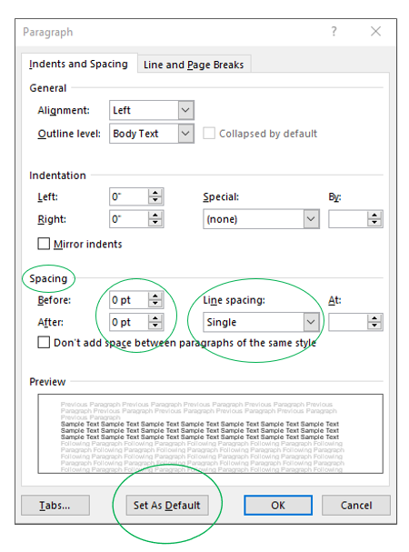 | 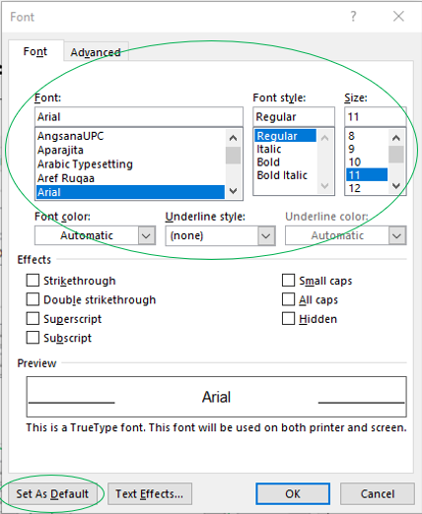

Special Provisions Template:
Open blank template:
https://www.mdt.mt.gov/other/webdata/external/contractplans/forms/SPECIALS_BLANK-TEMPLATE.DOTX

Special Provisions Training Video:
Special Provision Training - YouTube

Table of Contents
Use Table of Contents when there are multiple specials spanning several pages.

TABLE OF CONTENTS
FEDERAL AID PROJECT(S) PROJECT NUMBER(S)
1. PROJECT DESCRIPTION [102] 3

Once Specials are completed update your table of contents by:
- click the Table of Contents header or on Project description [102]
- click F9
- Select update entire table
- Click OK
Formatting Special Provisions
Please use the Styles provided in the template (Shown below). This enables a smooth transition when specials are being added to proposals.

Bid Packages Styles

Always start with 1. AABB (this level will populate the table of contents when updated.)
Levels continue in the following order:
- A. AaBb
- 1) AaBb
- A) AaBb
- (1) AaBb
- (a) AaBb
- i) AaBb
Remember:
Plain paragraphs are ok. (Use BidB Body Style)
Do not have an A without a B
Do not have a 1 without a 2
Use Bullet style when something needs to stand out and other levels don’t work.
No Bold (Bold is only used for Addendums)
No Underlining (other than level 1.)
No Track Changes
No colored or highlighted text
Tip: When you click on text in your document, the style applied to that text will be highlighted on the Styles Menu of Home Ribbon.

Formatting Tables
Insert table and apply BidN.Style This style has no special formatting

Have a hard return before your table and one after your table.
Table Text - use Arial font, size 11pt
Use Shading instead of Bold or Italic to make headings stand out (White, Background1, Darker 15%).
Use Table Formatting Layout Tools for text alignment (such as centering text) instead of using spaces or returns.
Example Special

- MODIFIED BRIDGE DECK CONCRETE WATER CURE [551] (REVised 7-11-19)
  - Description. Protect full depth bridge deck concrete from shrinkage and thermal cracking.
  - Materials.
    - Burlap. Furnish burlap in accordance with Subsection 717.01.2.
    - Water. Furnish water in accordance with Subsection 713.01.
    - Data logging probe. Submit for approval a temperature monitoring system having at least 4 channels, capable of measuring internal concrete and ambient temperatures, recording time and temperature at 30-minute intervals or less for a minimum of 14 calendar days, with an accuracy of 1 °F or less.
  - Construction Requirements.
    - For each concrete placement, install 4 probes at 3 locations on the deck (12 probes total per placement) in concrete a minimum of 5 feet away from any edge or joint. For placements that are less than 10 cubic yards, place only 4 probes at one location. Place and secure probes at 4 depths within the deck as follows:
- at least 2 feet above deck surface. This probe may be moved to the edge of deck to facilitate attachment;
- to the top of the top mat of rebar;
- midway between the 2 mats of rebar, and;
- to the bottom of the bottom mat of rebar.
    - Start recording temperatures at least 1 hour prior to concrete placement. Ensure probes read within 3.6 °F (2 °C). Replace probes that do not. Protect probes during concrete placement. Relocate any displaced probes within wet concrete. Monitor and record ambient air temperature while recording probe temperatures. Monitor concrete temperatures until concrete is within 5 °F (2.8 °C) of ambient, and vertical temperatures through the deck thickness are uniform (within 10 °F [5.5 °C]) and concrete is at least 96 hours old (72 hours old if concrete does not contain silica fume).
For cold weather concrete placements, monitor temperatures until cold weather protection is removed.
    - Increase ambient humidity by fogging above finished concrete and concrete forms/rebar using one or more 3000 psi (21MPa) or greater pressure washer powered fogging wands. Do not:
- use low pressure spray nozzles;
- use fogging systems attached to the screed;
- use fogging, or other methods, to add finishing water to unfinished concrete;
- allow water to drip, flow, or puddle on the concrete surface during fog misting, when placing the burlap, or at any time before the concrete has achieved final set.
    - Maintain the forward edge of concrete placement nearly parallel to and not more than 6 feet (1.8 m) ahead of the strike-off.
    - Use catwalk(s) to facilitate uniform application of the fog mist across the entire deck and to facilitate placement of the wet burlap on the fresh concrete surface. Apply a fog mist as necessary to maintain a moist surface on the finished concrete before and after covering with burlap until the water cure process is operational.
    - Start the water cure as soon as possible without damaging the concrete finish by applying pre-moistened burlap to maintain a water-saturated environment on the concrete surface. Meet the following requirements for the water cure.
      - Ensure the temperature of all water used in the water cure is within 20 °F (11 °C) of the in place concrete temperature.
      - Presoak the burlap by immersing it in water for at least 24 hours prior to placement.
      - Apply the wet burlap to the concrete surface no later than 15 minutes after striking off and finishing the surface of deck-slab concrete.
      - Place soaker hoses when the concrete has hardened sufficiently to prevent marring of the surfaces.
      - Keep the entire deck surface saturated for 3 hours (1 hour for cold weather concrete, unless otherwise directed by the Project Manager) after concrete has reached maximum temperature as recorded by the probes. Immediately turn off soaker hoses and apply clear plastic sheeting over the wet burlap to keep concrete moist.
      - Apply cold weather insulation blankets and/or cold weather protection systems to protect concrete and minimize the rate of cooling of concrete immediately following the installation of plastic sheeting.
      - Maintain concrete temperatures between 60 °F and 90 °F during cold weather concrete cure.
      - Remove all curing and allow deck to dry when concrete is within 5 °F (2.8 °C) of ambient, and vertical temperatures through deck thickness are uniform (within 10 °F [5.5 °C]) and the concrete is at least 96 hours old (72 hours old if concrete does not contain silica fume).
For cold weather concrete placements, remove curing and cold weather protection systems as required by 551.03.6
  - Method of Measurement and Basis of Payment. Fogging and water cure will not be measured separately for payment. Include all costs associated with this provision in the concrete receiving the cure.

EXAMPLE TABLE

PROPERTY | TEST METHODS | UNITS | REQUIRED VALUE^{1,2}
Ultimate Tensile Strength | ASTM D 6637 | lb/ft (kN/m) | Enter Value.
Tensile Strength at 2% Strain | ASTM D 6637 | lb/ft (kN/m) | Enter Value.
Geogrid Percent Open Area | CW-02215 | % | Enter Value.
Minimum Opening Size | Direct measure with caliper | in. (mm) | Enter Value.
Maximum Opening Size | Direct measure with caliper | in. (mm) | Enter Value.
Junction Strength | GRI GG2³ | lb (N) | Enter Value.
Ultraviolet Stability | ASTM D 4355 | % at 500 hrs | Enter Value.

Submitting Project Specials to ECCB

- Use the most updated special with the correct styles applied.
- If special has not been updated, copy/paste into the ECCB Specials Template.
  - Template:https://www.mdt.mt.gov/other/webdata/external/contractplans/forms/SPECIALS_BLANK-TEMPLATE.DOTX
- Check to see if the correct formatting styles are applied.
  - Instructions:https://www.mdt.mt.gov/other/webdata/external/contractplans/forms/SPECIAL_PROVISION_FORMATING_INSTRUCTIONS.DOCX
- Provide project specific specials only.
  - ECCB coordinates with the Spec Section and maintains current/updated versions of Standard Specials.
- To request standard specials in the contract, include the header/title of the special without any text. ECCB will insert the most updated version of the standard special. If the text of the special is included ECCB assumes that it has been modified from the “standard” version and will not insert the most current version.
- Save documents in PCMS and provide links on the Transmittal Form.
- When project specific specials are updated after PSE or PRE review, re-submit updated specials separately and name them “updated” to avoid confusion.
- Do not send documents with track changes to ECCB.
- Do not submit PDF documents.
- Test links added to specials to ensure they work.

